Peter Julius M. Estacio
Grouped with:
Niño Aloysius V. De Mesa
Christian James S. Madariaga
ENGG 151.01-A
April 15, 2026

Progress Report 2 for Project 3: Linear Time-Invariant System Simulator

As of April 15, 2026, progress has been made as the functions for parsing signal and system files have been implemented properly. First, the function for parsing signal files was adjusted instead to a void function, instead modifying arrays initialized in the main function for both the input and output signal values. This is so that these arrays can then be passed for the LTI simulation functions in the future. From there, the function for parsing system files was programmed, storing all a-coefficients and all b-coefficients in their respective dynamically allocated arrays. Lastly, progress includes printing to console all parsed input signal values, output signal values, and LTI system parameters. This is all in preparation for the LTI simulation itself, which is not implemented yet but will be done for Progress Report 3.

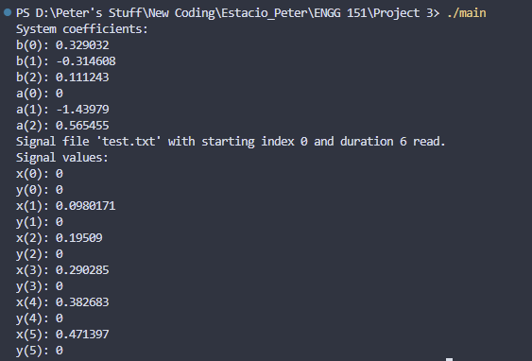
sample screenshot – executable main.exe run and resulting output to console

sample screenshot – compilation on Visual Studio Code

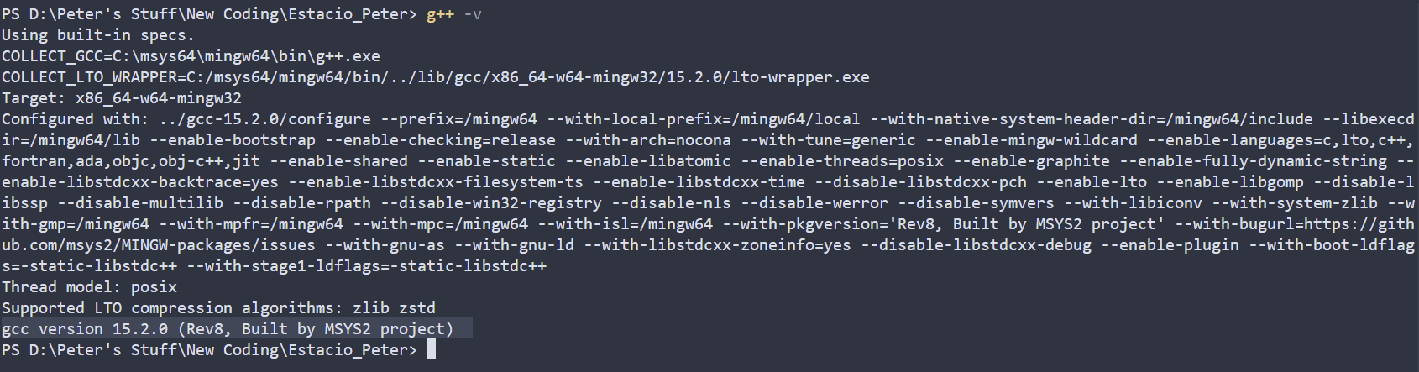
compiler version – gcc version 15.2.0 (Rev8, Built by MSYS2 project)

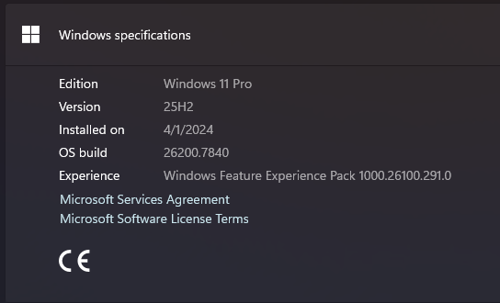
operating system - Windows 11 Pro, 25H2, build 26200.7840

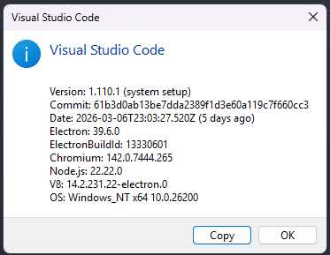
IDE – Visual Studio Code ver 1.110.1

